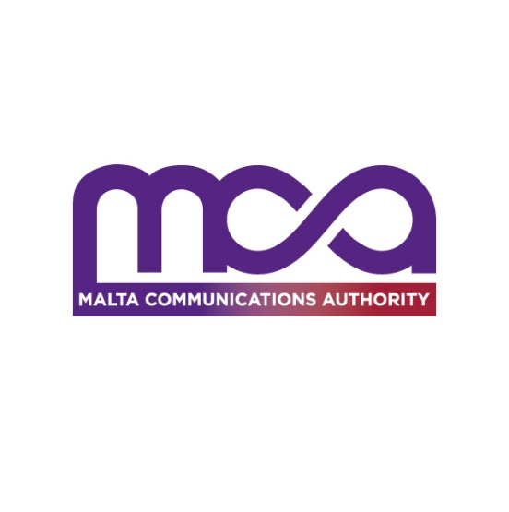

4th February 2021

**MCA Consumer Perceptions Survey reports strong take up of telecoms in bundle subscriptions**

**Main survey findings**

The MCA is hereby publishing the findings of a survey gauging consumer perceptions based on their experience in purchasing bundles in Malta. Key themes relate to the composition of bundles, level of satisfaction with the service, consumer sensitivities to price changes and propensity to switch.

The survey was carried out by EMCS on behalf of the MCA via telephone interviews, with the number of randomly selected respondents totalling 847.

**Strong take-up of bundles, mainly triple-play**

94% of all survey respondents say they have a bundle subscription. Of all these respondents, 39% say they have a triple-play subscription being the most prevalent. A further 36% of survey respondents on a bundle subscription say they opted for a quad-play offer consisting of mobile telephony alongside the aforementioned electronic communications services. Meanwhile, 15% of survey respondents subscribed to a bundle say that the dual-play option is their preferred choice.

The proportion of respondents on a bundle subscription has gone up consistently over the years, particularly as the local stand-alone line-up dwindled.

**Discounts and single billing drive take-up of bundles**

65% of respondents with a bundle subscription say that single billing is a convenient and positive feature of bundles. Another 43% of respondents with a bundle subscription say that the availability of discounts and promotional offers were another main reason for their selection of a bundle instead of stand-alone products.

**Subscribers to bundles generally know their monthly expenditure**

74% of respondents subscribed to a bundle say they know their average monthly expenditure on their bundle subscription.

When it comes to monthly expenditure, specifically the monthly outlay on access fees, 52% of respondents with a bundle subscription that know their expenditure say this exceeds €50.00. This

percentage is 21 points higher than reported in 2017. An additional 41% of respondents knowledgable of their bundle expenditure reported an expense of between €30.00 to €49.99, down by 11 percentage points from what was reported in 2017.

When it comes to how expensive the bundle product is perceived to be, 35% of respondents that are bundle subscribers say this is expensive (5 percentage points less than in 2017) whilst 60% consider it reasonable (18 percentage points higher than in 2017). 4% of those respondents who are subscribed to a bundle did not have an answer to the respective question.

**High satisfaction levels with an overall percentage increase from 2017**

83% of survey respondents say they were generally satisfied or very satisfied with the quality of service of their bundle subscription. Furthermore, the 2020 satisfaction rate is up 8 percentage points than that recorded in 2017.

5% of respondents with a bundle subscription deemed their quality of service to be unsatisfactory, whilst another 13% felt indifferent on the quality-of-service aspect.

Frequent disconnections and billing issues were mentioned prominently by respondents expressing dissatisfaction with the quality of service.

Meanwhile, 87% of respondents saying they experienced a fault with their bundle subscription expressed satisfaction with the level of fault resolution measures provided by their operator.

**Very limited switching even in the prospect of a price increase**

5% of survey respondents with a bundle subscription have switched service provider in the two years prior to the survey date. This is 3 percentage points more than what was recorded in the 2017 survey.

Survey data also shows that few respondents would actually switch their bundle subscription from their current service provider if monthly access fees were to go up by 10%. Of significance is that 47% of survey respondents say that, in the event of a 10% increase in price, they would keep their current subscription. 31% of respondents would however switch to a new service provider.

**Background to the survey function at the MCA**

The MCA has been carrying out the Consumer Perception Surveys on a two-yearly interval since 2008. The aim is to gather information on the level of consumer satisfaction with the products and services on offer and the extent to which service providers address the demands of their clients. Given that these surveys have been carried out for a number of years, survey findings are indicative of developments in the needs of the end-user and how local service providers deal with changing preferences.

The results of these surveys also serve as an additional source of information for the MCA’s regulatory decisions, in order to ensure an environment that is conducive to sustainable competition and investment in view of the growing demands of the future.

**Methodology and Fieldwork**

The methodology used to carry out this survey, including the sampling, questionnaire design, fieldwork and weighting processes follows the same approach adopted when carrying out similar surveys in previous years.

The research methodology involved the use of Telephone Computer-assisted interviewing (CATI).

Consumers sampled were stratified according to the age composition of the Maltese population. Moreover, the interviews were distributed among Malta’s six official geographic regions and carried out across different socio-economic categories of the Maltese population.

For a more comprehensive picture of survey findings, a presentation encompassing the main survey findings is available on the MCA website via this link.